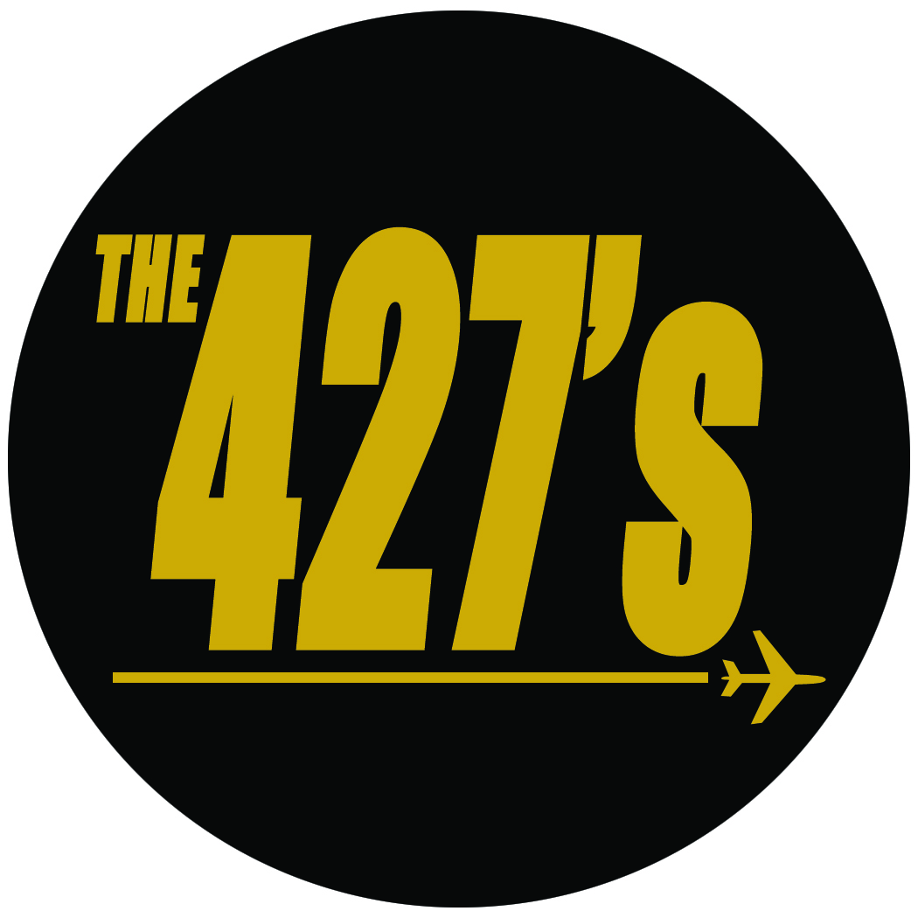

TECHNICAL RIDER
Fall 2018
the427s.com

Chris van Keir
Email: chris@the427s.com
Phone: 1-403-975-7047

- Chris van Keir: Lead Guitar
  - Guitar -> Reverb Unit -> Amplifier -> Board
- Rob Day: Rhythm Guitar
  - Guitar -> Reverb Unit -> Amplifier -> Board
- Eve Hell: Bass
  - Bass -> Amplifier -> XLR Out -> Board
- Wrayne Ramone: Drums
  - Kick -> Snare -> 1 x Rack -> 1 x Floor -> Hi-Hat -> 2 x Crash -> Ride
- *Trumpet, Saxophone, and Keys Players may be added to the lineup, so please confirm with The 427’s prior to performance (see stage plot)

*The 427’s are entirely instrumental; vocal mic’s needed only for introductions, etc.

The 427’s will provide:
- All guitar & bass amplifiers (unless specified “backline provided by venue”)
- Drums, drum throne, cymbals, & hardware (again, unless specified)

The venue will provide:
- All microphones, stands, & cables (10 inputs, minimum; see stage plot)
  - 4 x drum mics (minimum)
    - Kick, Snare, 2 x overheads
  - 2 x guitar amp mics
  - 1 x bass mic
  - 1 x bass DI
  - 1 x vocal mic (*see above note)
  - 1 x DI for samples and XLR out from bass amp
- 1 x DI boxes (for audio samples)
- Four stage monitors
- Sound tech
- Backline requirements on page 2:

TECHNICAL RIDER
Fall 2018
the427s.com

Chris van Keir
Email: chris@the427s.com
Phone: 1-403-975-7047

Backline requirements:
  - One Ampeg or Markbass bass amp (300 watt min) with 4 x 10 cab
  - One Fender Twin Reverb
  - One Fender Bassman
  - Ludwig 4-pc kit with 22” kick, 16” floor tom, 13” rack tom, 14” snare
  - Three cymbal stands and One hi-hat stand
  - Zildjian A Custom cymbals (18” and 19” crashes, 21” ride)
  - Two XLR out from DI’s for bass and audio samples

- One table for merchandise (unless a merch area already exists)
- Four bottles of iced Perrier or comparable
- Four stage towels
- Four bags of Hawkins Cheezies
- Four tabs of Orange Sunshine
- Toothpaste
- One Prevost XLII (Liberty or Marathon)

Logistics, please answer the following via email:
- What is your merch policy?
- What time is load-in & soundcheck? What time is load-out?
- Is this an all-ages show?
- What time do doors open?
- Are tickets available in advance or at the door? What is the ticket price?
- What is the line-up and what is our set-time? What is our set length?
- Is there parking available? Is there a green room/backstage area available?
- What are the provisions for food/beverage?
- What is the house manager’s contact information?

